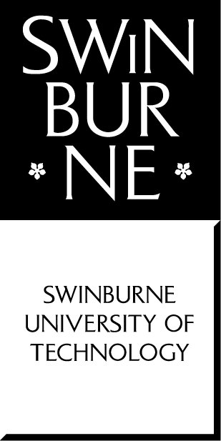**School of Science, Computing and Engineering Technologies**

**COS10025**

**Technology in an Indigenous Context Project**

**Final project reflection report**

Project Title: WATER PURIFICATION SYSTEM USING RENEWABLE ENERGY IN YUENDUMU COMMUNITY

Student Name: Trung Kien Nguyen

Student ID: 104053642

Date: 28/05/2023

**Declaration**

I declare that this report is my individual work. I have not copied from any other student’s work or from any other source except where due acknowledgment is made explicitly in the text, nor has any part of this submission been written for me by another person.

**Signature: Kien**

## Acknowledgement Of Country:

**The Wurundjeri People of the Kulin Nation owned the land on which Swinburne's Hawthorn campus is situated in Melbourne's east, where this report is based.**

**I gratefully honour the grounds of Wurundjeri Country and its history, culture, and spirituality.**

**I also acknowledge and respect all Aboriginal and Torres Strait Islander Nations' ongoing sovereignty as well as the Elders, Ancestors, customs, and legacy of the Traditional Owners of all lands in Australia.**

## Part A:

### Introduction (Project Description)

Our project for this unit - "Water Purification System Using Renewable Energy in Yuendumu Community" aims to address the fresh water shortage problem faced by the remote Indigenous township of Yuendumu.

Located about 293 kilometers to the northwest of Alice Springs in the Northern Territory, Yuendumu is home to one of Australia’s most resilient Indigenous Communities, which is the Warlpiri. In spite of its cultural richness and historical values, the township currently confronts significant environmental and physical challenges, especially the lack of clean pure water. The contaminated water sources that are currently existing make them dangerous to drink and use. When the local residents have to rely on such limited water supplies, their health, and quality of life are daily affected adversely.

Especially, due to the reliance on unfiltered and impure water sources, waterborne diseases such as parasite ailments and gastrointestinal infections are common in the community, according to a ABC’s article [1]. In order to address the community's water-related problems, it is necessary that a dependable and sustainable water purification system be put in place.

Our proposed project focuses on harnessing renewable energy sources to power an innovative water purification system. We aim to create a self-sustaining system that lessens the community's reliance on fossil fuels and helps to find a more environmentally friendly solution by incorporating and integrating renewable energy technologies, such as solar energy. In addition, besides the long-term benefits within the Community, this strategy also supports worldwide initiatives to slow climate change and encourage sustainable development in rural areas.

### Recommended option to proceed

After a number of discussions and considerations, we have together recommended the chosen design idea for our water purification system's project in Yuendumu Township is the implementation of photovoltaic (PV) panels in solar water purification. This design idea offers numerous advantages and positive impacts and opportunities for present and future use, making it highly suitable for the local community.

The idea’s system goes through several significant procedures and stages, such as pre-treatment, purification, and antibacterial process. Pre-treatment entails clearing the water’s debris and particles. The water is put through a succession of filters during the filtration stage to get rid of potential dirtier items, and microorganisms. The residual germs in the water are then eliminated during the disinfection process using ultraviolet radiation. After that, the cleaned water is kept in a tank for later use.

The integration of photovoltaic panels in solar water purification/filtration for the Yuendumu Indigenous Community offers several proper major benefits. Initially, it ensures a *reliable and sustainable water supply* for the community by harnessing solar energy. This reduces the community's dependence on traditional energy grids, or non-renewable energy sources like fossil fuel, and provides a continuous source of clean and safe drinking water. Secondly, the design concept uses PV panels to provide efficient functioning. After the original installation expenditures are paid for, Yuendumu Township's plentiful solar energy will be predominantly used for the system's continued operation. As a result, the operational costs related to traditional energy sources, such as electricity or fuel, are *greatly reduced*. Long-term sustainability can be promoted by allocating the cost savings accumulated over time to other significant community development initiatives. Furthermore, the Northern Territory receives the second-highest amount of sunlight in Australia on a yearly basis [2], making solar energy an attractive renewable resource for powering the water purification system, enabling the future usage. The plan contributes to the worldwide effort to combat climate change by lowering glasshouse gas emissions and minimizing ecological effects while also encouraging sustainable practices within the neighborhood.

Following those benefits, the PV panels’ design idea also impacts efficiently and positively the local lives in Yuendumu. Primarily, it significantly enhances outcomes in terms of *public health*. The system makes sure that the residents receive safe drinking water lowering the risk of water-related illnesses and improves general well-being. Then, this idea has the potential to provide jobs for qualified workers in the indigenous community who will be in charge of system maintenance, operations, and repairs for the solar water purification system. It emphasises technical training for the locals, supporting their independence, and advancing social and economic inclusivity. By actively incorporating the community in system operation, these employment and training opportunities can boost incomes, support local economic growth, and contribute to the reduction of poverty levels, paving the way for a more sustainable future for Yuendumu Community.

On the other hand, some potential constraints also need to be identified. One such challenge is the initial investment required for installing the system. Even though the cost of solar technology has decreased recently, particularly in the operational phases, there may be financial barriers to acquiring the required tools and equipment, such as high-quality PV panels, regulators, specialised water treatment pumps and reservoirs, as well as IoT and AI monitoring tools and software. Last, but not least, maintenance and repair of the system may require technical expertise, other than local staff. Operating the system may be an uncomplicated and accessible process for the locals of Yuendumu Township, but maintaining and repairing of the system, especially in the event of a breakdown or accident, will need the industry's leading engineers and experts to solve. That can disrupt the water purification system for a few days, or even a month, affecting the daily life of local people.

In conclusion, the idea of utilizing photovoltaic panels in solar water purification offers substantial positives and effects for the locals in Yuendumu Township. It provides a reliable and sustainable water supply, improves public health, promotes environmental stewardship, and presents opportunities for economic and educational development. However, potential disadvantages such as the initial investment, maintenance requirements, should also be taken into consideration during the implementation and operation of the system.

### References

[1] Beavan Katrina, 2019, Yuendumu in Central Australia at ‘severe risk’ of running out of water; <https://www.abc.net.au/news/2019-08-13/remote-community-yuendumu-running-out-of-drinking-water/11405024>; Published by ABC (Australian Broadcasting Corporation).

[2] Unknown Author, December 2022, A Breakdown: The Australian State That Gets The Most Sunshine; <https://energymakeovers.com.au/blog/a-breakdown-the-australian-state-that-gets-the-most-sunshine/>; Published by Energy Makeovers.

## Part B: Project reflection

### Group Work Reflection

1. Describe the group work strategies/processes that worked for your team.

In my opinion, for this project, our team has used a variety of successful group work strategies:

* The whole team placed a high priority on open, honest communication through routine meetings, making sure that everyone was in agreement with the project's objective, which is solving the problem in Yuendumu community.
* Our ability to use a variety of skills and make educated decisions was facilitated by collaborative decision-making. Based on each individual's strengths, tasks were delegated and progress updates were made to resolve any problems. E.g. I was responsible for project management while Truong was to find high-quality related resources.
* Through brainstorming and helpful criticism, all of us promoted a creative environment. Accountability made sure that everyone fulfilled their obligations, and a supportive environment encouraged and supported one another. E.g. Nuyang Rai suggested that we should have added wind turbines using as a new design idea.

1. Describe the group work strategies/processes that did not work for your team.

While our team implemented several effective group work strategies and processes, I believe we also encountered some challenges.

* Time management, as we all struggled to adhere to deadlines consistently. E.g. I and some others were a bit confused when faced with this unit's exercise at the same time as the other units.
* Sometimes, especially in the initial weeks, there is still a reactive approach to problem-solving that hindered progress, and an imbalance in individual workloads affected team productivity. E.g. Promit was confused about week 6 activities, leading him to submit late a bit.

1. Describe what could be improved on next time you work in a group. This should be from your individual perspective, e.g., "not working with person X" is not something **you** can change.

In future projects*, I would share with new members the experiences of this project*, including developing effective strategies, and avoiding the obstacles:

* Enhancing communication skills by actively listening, expressing thoughts clearly, and seeking clarification would help avoid misunderstandings.
* Being more active in problem-solving, by identifying challenges early and providing suggestions for solutions, would contribute to smoother progress.
* Improving time management skills, setting realistic deadlines, and allocating time for unforeseen delays would enhance overall efficiency.
* Embracing collaboration, valuing diverse perspectives, and being flexible would foster a more productive group dynamic.
* Seeking more feedback from the teammates and tutors/facilitators and engaging in self-reflection during the project implementation would allow for continuous growth as a team member.

1. Describe an event/action in your team (i.e., not just from you) that you think was outstanding with respect to each of:
   1. Team organisation

All team members have together aggred a project management in the first place. This allowed us to track tasks, deadlines, and progress efficiently. E.g. Besides the compulsory parts of each person, I took the responsibility for submitting and asking tutors for guidances in the meetings, while Steven Truong and Ethan Lee were assigned with the roles of finding trustable resources, and references in almost tasks, ...

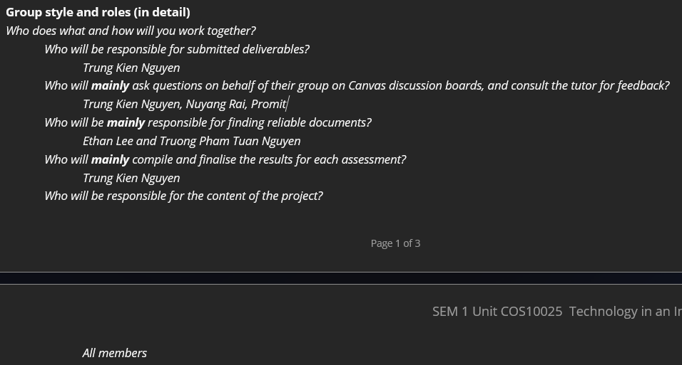

* 1. Meetings

In the workshops, most of us discussed and basically gave solutions to the problems that arise during the weekly activities.

And in the online meetings, most of us participated in the weekly submission, consulted with the tutor, although sometimes there were still a few members who joined/submitted late, e.g. Promit seemed to be busy in some weeks.

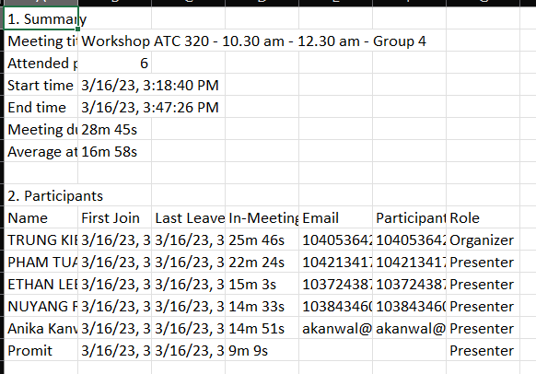

* 1. Delivery of the project design ideas

During the first few weeks, The whole team worked together and discussed the technologies that should be used for the project, from which each of us came up with 5 design ideas that we thought were the best. E.g. During weeks 3 and 4, I and Ethan Lee suggested three different series of references to discuss Yuendumu's water issue, including media companies (SBS, ABC), government organizations (AIATSIS, indigenous.gov.au), and non-government organisations’ sources (Wikipedia)

* 1. Delivery of the Innovation concept

All members have basically completed the tasks and requirements of the Innovation Concept, including the introduction and conclusion, details of all 5 design ideas about concepts, methods, benefits, influences and limitations, with accurate references, except for a few issues that have been pointed out such as not focusing much on Township. (Evidences: Submitted to Canvas)

* 1. Delivery of the final presentation

The whole group discussed and divided specific roles in the final presentation, although there were still many limitations such as formatting the presentation file, questions, and conclusions. E.g. Ethan Lee volunteered to present the opening and introduction parts, while I, besides my own design idea, synthesized and evaluated other ideas and came up with a recommended one.

### Individual Work Reflection

* Project tasks
  + Describe your tasks in the group project in each phase of the project (add evidences)
    - Phase 1 – Identifying township and the team problem

I gave 5 different townships for the party to decide on "Yuendumu" in the first place. I was also the one who suggested changing the title from "Health Management" to "Water shortage" according to the tutor's feedback, as you told to my tutor in the Week 3 Online Meeting.

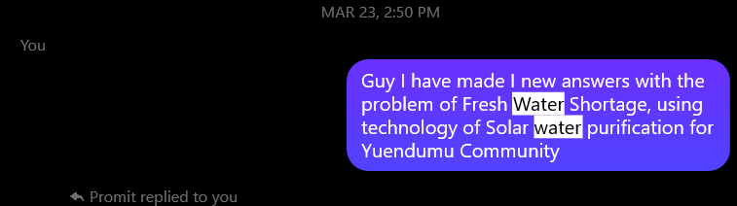

* + - Phase 2 – Develop design ideas, Use design criteria to make standard design ideas, Analysing the benefits, impacts of each design idea

I am the one who came up with the idea of using renewable energy such as solar energy for water purification, thereby helping the members to be oriented in developing their own design ideas. (Evidence is above)

* + - Phase 3 – Design justification (using score sheets) by scoring the six guidelines

I evaluated and justified my design idea 1, and after receiving the results from my tutor in week 7, I also added more and discussed with the team the evidences of design ideas 1, 3, 4, and 5.

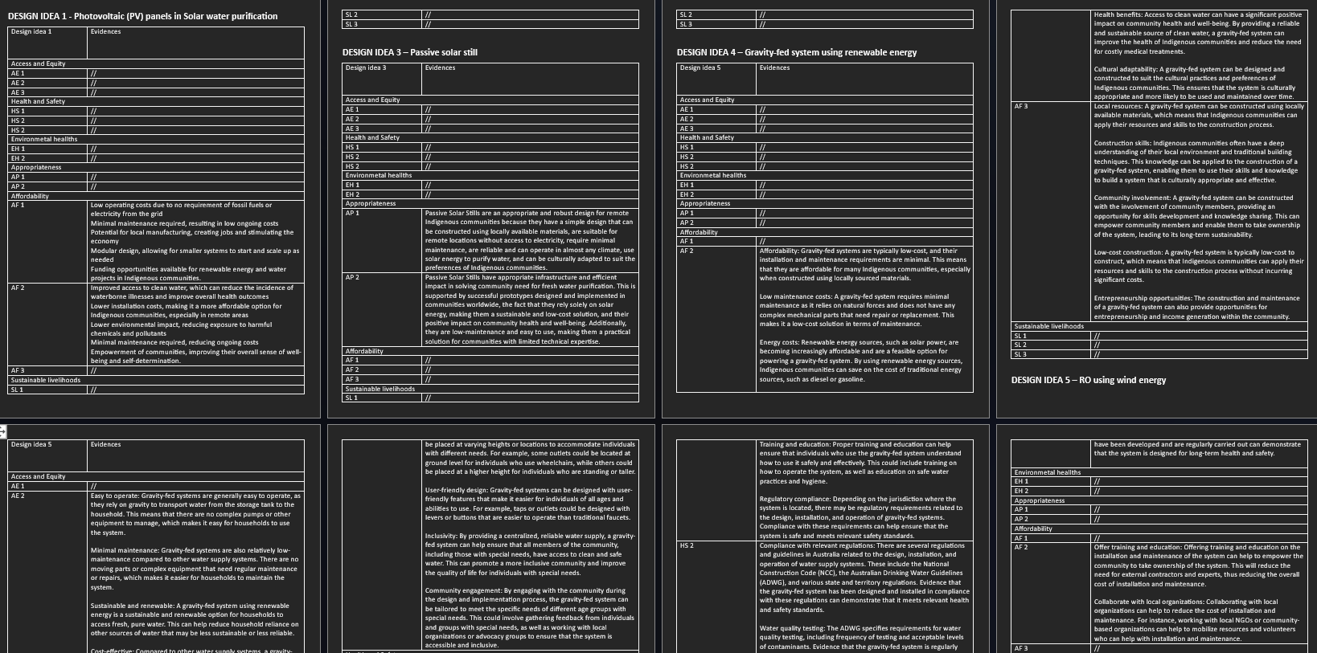

* + - Phase 4 – Analysing design average score sheets and improvising design ideas

I was the one to lastly check and evaluate the design ideas before the presentation, to give the recommended one, I also had added more evidences for each design idea previously (Evidence is above).

* Contributions to the group
  + Describe how your efforts contributed to the whole group

My active engagement and contributions made a significant impact on the success of the whole group (30-35% of the workload). As a member, I played a key role in contributing to the project's ideas and actively participating in the development of the innovation concept and final presentation.

* + Describe how you were involved in the teamwork environment

As the team leader, I played a key role in implementing the project management, finalising and submitting task, leading the discussions, and actively asking and receiving feedback from the tutor. Through my efforts, I helped ensure effective collaboration, and communication within the team, ultimately contributing to the overall achievements.

* Conclusion and recommendation
  + Conclude your achievement in accordance with the culturally suitable solution (you can pick either 1 or 2 design ideas that suit well)

Our team's final idea of the culturally suitable solution of using PV panels for water purification in Yuendumu Township has been a significant achievement. By implementing this idea, we have addressed the water purification problem while respecting the cultural values of the indigenous community. As the mentioned benefits of the use of PV panels, it sets a precedent for sustainable solutions in remote Indigenous townships, contributing to the well-being and self-sustainability of the Yuendumu Community.

* + Recommend how you could further improve your design ideas within a team environment

To further improve our design ideas within a team environment, I can:

* Focus on discussing more with the team members to develop the good points and reduce limitations, fostering a sustainable and culturally suitable water purification system.
* Assign members to search for information about similar projects that have been implemented or planned, and if possible, do empirically survey the actual situation in Yuendumu Township to follow up and demand more closely the locals’ needs.

## Part C: Unit Learning Outcomes (ULOs)

1. Locate Indigenous knowledge systems and consider how they story the long history of technology, science, and engineering. (add evidences)
   1. Understanding and exploring Indigenous knowledge systems

When putting the concept of our project into practise, we would work closely with the Yuendumu people to gain a deeper understanding of their extensive knowledge by actively listening to their stories and traditional values, especially those relating to water issue. We want to make sure that our project utilised and respected Indigenous knowledge systems. Evidence [3]

* 1. Ensure the project was undertaken in accordance with locating Indigenous knowledge systems (Technologies)

By honoring Indigenous knowledge systems when doing this project, we would recognize the contributions they make to the fields of technology, science, and engineering, iming to empower the community, foster cultural pride, and contribute to a more inclusive discourse on technology and engineering. Evidence [4]

1. Explain the importance of, and find opportunities to, respectfully converge Western knowledge systems with Indigenous knowledge systems. (add evidences)
   1. Brainstorming the importance of Indigenous knowledge systems

In our research on the value of indigenous knowledge systems, we have found that they provide important knowledge about the environment, natural resources, and sustainable practises. For instance, Yuendumu is one Indigenous community that has a profound understanding of traditional healing methods, land management strategies. Evidence [5]

* 1. Understanding the Indigenous knowledge systems and uniting with Western knowledge systems

We can close the gap between the two knowledge systems and capitalise on their individual strengths by entering into meaningful relationships and communication, enabling the interchange of knowledge, skills, and best practises, resulting in creative solutions that are appropriate from a cultural, social, and environmental standpoint. Evidence [6]

* 1. Understanding and applying correct use of terminologies

When addressing and preserving Indigenous knowledge systems, it is crucial to honour and respect indigenous languages and vocabularies. This guarantees that their ideas, categories, and methods are accurately portrayed and preserved. Evidence [7]

1. Apply relevant knowledge of emerging technologies to a project within an Indigenous context taking into consideration and acknowledging Indigenous histories, worldviews, standpoints, and cultures. (add evidences from weekly workshop team activities, weekly seminar reflections, assessments)
   1. Analysing the challenges, needs and services for the remote Indigenous community

The Yuendumu community's unique cultural and environmental background was taken into account as we performed in-depth study and held in-depth talks. We investigated the particular difficulties people had in getting access to clean water and noted the gaps that coming technologies might bridge.

* 1. Explore user access, affordability, appropriateness in relation to the design ideas

Our team critically assessed the viability and practicality of implementing emerging technologies in the Indigenous context through our weekly seminars and assessments. We took into account variables including resource accessibility, cost-effectiveness, and the degree of technical know-how needed for operation and maintenance.

Evidence [1], [8]

1. Function as an effective team member using project management tools and demonstrating professionalism and ethical behaviour. (add evidences)
   1. Attended team meetings, facilitator meetings and workshops

I did not miss any meetings, workshops or discussions during the time of the unit. Evidences as shown in the meeting attendences (Available in the facilitator meetings’ Ms Teams Chat)

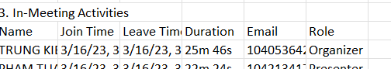

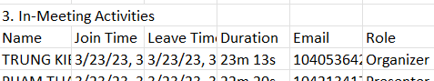

* 1. Assisted in planning for the team

As a team leader, I was primarily responsible for planning the entire team for the reviews, as well as the entire project. I am the same person who arranged and assigned tasks and responsibilities to the members.

* 1. Delivered work on time for the team

Obviously, I have always completed my work before the deadlines, as demonstrated on the canvas.

1. Communicate within teams, stakeholders using appropriate verbal, written, and technological approaches. (add evidences)
   1. Contributed to team meetings

I have been the most active in meetings, including classifying roles and tasks, discussing and receiving ideas from tutors, ...

* 1. Engaged with facilitator meetings

As I mentioned, I firmly belive that I was the most active member in the discussions, including facilitator meetings.

Evidences for a, b as shown above, and the meeting attendences.

* 1. Proficient in verbal communication, both presentations and conversation

I showcased moderately in delivering clear presentations that effectively convey my ideas and project progress.

* 1. Proficient in written communication, both reports and online interaction

I produced organised, thorough reports that clearly, accurately, and thoroughly described my research, the design process, and the project outcomes. The submissions through Canvas were evidence of my great written communication abilities.

* 1. Made use of other tools (e.g., online brainstorming tools) to interact with others

I actively utilized various online tools, including Google Documents, ChatGPT, to collaborate with team members and engage in interactive discussions, contributing valuable insights and ideas to the project

1. Appreciate emerging technologies in a local, global and sustainable context (add evidences)
   1. Considered a culturally appropriate design idea

My design idea (PV Panels) ensured that the suggested solution was in line with the specific cultural context of the Yuendumu Township, respecting their own cultural perspectives, knowledge, and values while fostering a sense of ownership and acceptance of the technology within the community.

* 1. Explored sustainable livelihoods in relation to the design idea

The possible long-term effects and advantages that the technology could have for the community were analysed and considered most. This involved assessing how it may benefit the community's overall well-being, access to resources, and economic prospects. We intended to develop a solution that not only met urgent requirements but also encouraged long-term resilience and self-sufficiency by taking into account the sustainable livelihood components.

Evidences as shown in **Part A**, as my idea is also the recommended design idea.

### References

[3] Unknown author, Yuendumu - Same Jukurrpa Same Country; <https://artsandculture.google.com/story/igWRa-ZVwBfLKw?hl=en>; Published by Australian Museum.

[4] Melinda Hinkson, 2002, New Media Projects at Yuendumu: Inter-cultural engagement and self-determination in an era of accelerated globalization; <https://www.tandfonline.com/doi/abs/10.1080/10304310220138769>; Published by Carfax.

[5] Unknown author, 2015, Northern Tanami Indigenous Protected Area Plan of Management; <https://www.clc.org.au/wp-content/uploads/2021/04/Northern-Tanami-IPA-Plan-of-Management.pdf>; Published by CLC (Central Land Council)

[6] Madison Snow and Tom Forrest, Feb 2022, Mixing traditional knowledge with western science, <https://www.facebook.com/watch/?v=1027894227795971>; Published by ABC

[7] Catherine Bow, October 2016, Using authentic language resources to incorporate Indigenous knowledges across the Australian Curriculum, <https://livingarchive.cdu.edu.au/wp-content/uploads/2014/03/LCJ_2016_Bow.pdf>; Published by Charles Darwin University

[8] Unknown author, Western Water Study - Hydrogeology of the Yuendumu - Papunya - Kintore Region; <https://data.nt.gov.au/dataset/western-water-study-hydrogeology-of-the-yuendumu-papunya-kintore-region>; Published by Data Portal of NT Government.